

Project no.12 – Spy Agency

*Computer Science*

**Object Oriented Programming**

Filip Korzeniewski

Album number 293070

Lectures: dr inż. Roman Podraza

Laboratories and Project: dr inż. Piotr Wąsiewicz

Warsaw 2018

Spis treści

1. Goal and story 2

2. Diagram of Agency’s hierarchy 4

3. Memory mapping 4

4. Class description 5

People class – Base class 5

Spy class – derived class 5

Agent class – derived class 5

Office worker – derived class 5

Intelligence service – group class 5

Secret service – group class 6

File class 6

Government class – control class 6

5. Declarations of classes and functions 7

Declaration of class Government 7

Declarations of Groups class – container class 8

Rest of class declaration 9

6. Testing 11

# Goal and story

The software represents a scenario of a spy agency managing system. The purpose of the simulation is to create a coded interface where user can add data of the spies, secret service agents, intelligence services. The software can simulate the spies competitions and prizes that are able to win. The spies will belong to Secret service which will be tantamount to government. The Intelligence service agents will also belong to government.

The competitions will be evaluated by comparing the data of each spy. The data value of each file he took over, the fact if he got caught or not and if he got – how many years he served his service.

Story:   
A government class is created. The government can have multiple spies and service agents. The data of the spies in secret service is compared and the prize is awarded to the best spy in agency (overall), for most valuable file that spy took over (all category is evaluated for certain number of points and adding).

Government scenario:

-government can be created

-government can have only one intelligence service or none

-government can have only one secret service

-government gathers points of spies and secret agents and compare it in 2 groups

-government has the hierarchy as shown: intelligence service separately with service agents; spies belongs to the secret service

# Diagram of Agency’s hierarchy

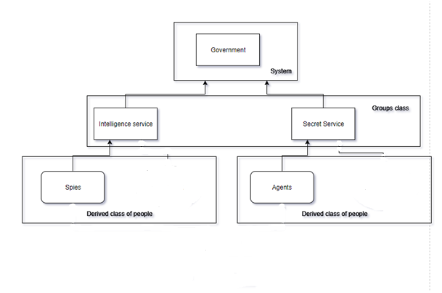

# Memory mapping

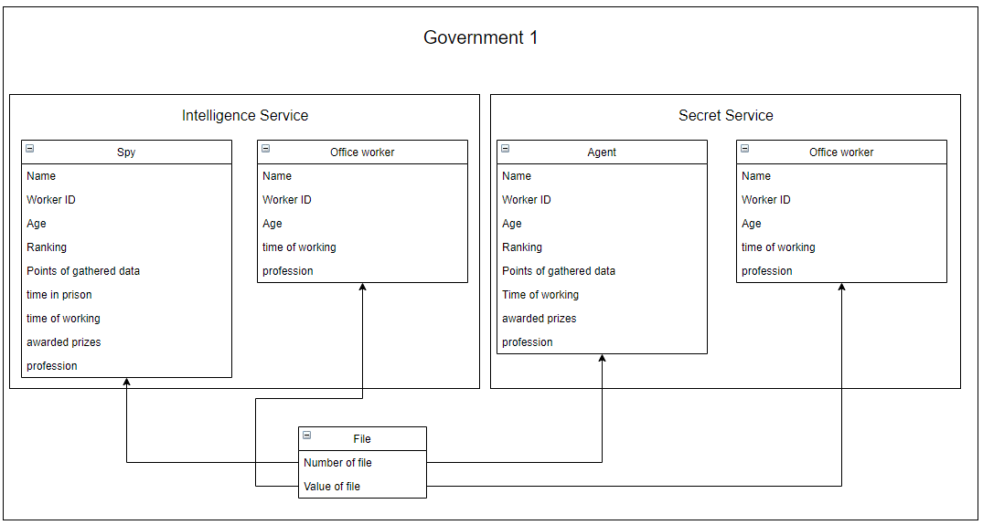

# Class description

## People class – Base class

The people class is a base class of the people of the Spy Agency’s simulator. The people are spies, office workers, agents.

## Spy class – derived class

Spy class is a derived class of the People class, its parent class. Most of the attributes of the class is derived from its parent class.

## Agent class – derived class

Agent class is a derived class of the People class, its parent class. Most of the attributes of the class is derived from its parent class.

## Base_Group – Base class

The Base_Group is pure abstract class that is base class for groups Intelligence service and secret service. It has included methods mutual for intelligence and secret service groups like granting awards, comparing workers (setting ranking based on file value or value and time in prison of each agent) function, counting members of group and firing members with using ID or name of worker.

## Intelligence service – group class

Intelligence service class has function of recruiting new agents and printing their data. It has also all function derived from base class.

## Secret service – group class

Secret service class has function of recruiting new spies and printing their data. It has also all function derived from base class.

## Government class – control class

Government class has access to every function. It can give award for some spy or agent, hire and fire spies and agents. It can also disband intelligence service or secret service, and created new one (max one at the same time).

# Declarations of classes and functions

## Declaration of class Government

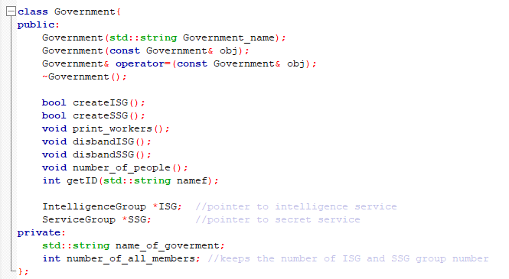

## Declarations of Groups class – container class

The groups class is a container class which has linked list of people in. This is the base class. Intelligence service class and Secret Service class are the classes that are derived classes that separate members.

The derived groups class takes people only from their professions. When the people are “hired”, the profession is set by parameter of which institution was hiring the worker. If secret service hires the worker, it will be a spy. If Intelligence service hires the worker, it will be an Agent.

Groups class can “recruit” and “fire” people.

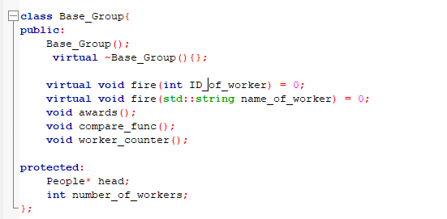

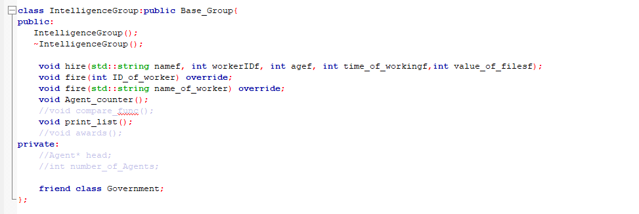

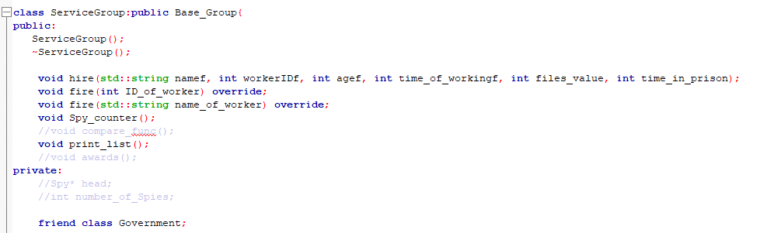

## Rest of class declaration (people):

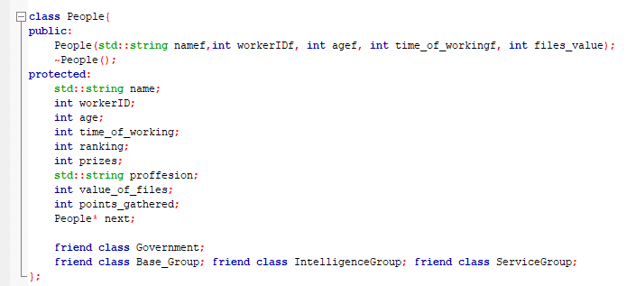

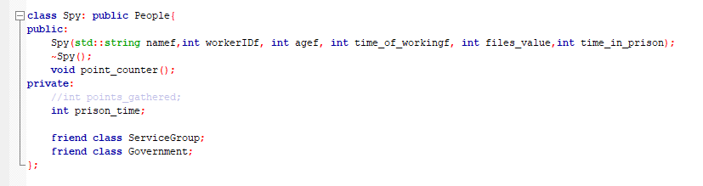

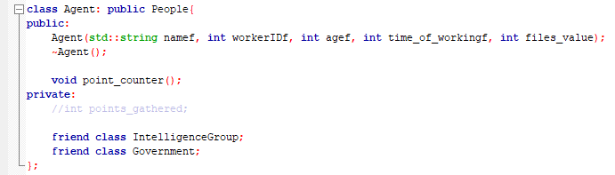

# Testing

The testing should work for all cases, actions and events of the class. In every case the proper action should be done – either simulate one or the notification for user that something is wrong. In final project it is good to print all the list and see if everything is good.

Pretending the situations:

-cannot fire agent nor spy that name does not exist

-cannot fire agent nor spy that ID does not exist

-cannot print empty list – instead it gives the text on

-cannot create second intelligence service

-cannot create second secret service

